**Diploma in Software and Design**

**Assignment Cover Sheet**

|  |  |  |
| --- | --- | --- |
| **Student’s name:** Sonali | | |
| **Module 2 Object Oriented Programming and Data Structures (25 credits)** | | |
| **Assignment title and/or number**:  DSED05 C# Classes Assessment | | |
| **Assessment weighting** | | *Need to pass the assessment to complete the course* |
| **Passing Criteria:** | | Need to score 50 or more marks to pass the assessment.  **Total Marks : 100** |
| **Due date**:  June 30, 2020 | | **Date submitted**:  (late submissions incur 10% penalty, after 7 days late, the assessment will not be marked) |
| **Assessment conditions:** | | This is a resource-based assessment. This means that you may have access to any relevant resources to assist you. This could include, for example, your learning materials, information on the Internet, and so on. However, all work must be your own with no assistance from any other person. |
| **Submission requirements:** | | You’re required to upload the following on Cloud Campus:   * This document, completed where appropriate * Visual Studio project files * Upload your project on Github and paste the link below   GitHub Link: <https://github.com/sonalisharma8146/Sonali-Bet-Game> |
| **Learning Outcomes:** | * Coding – object oriented, procedural; * Construct software with complex, multi-element architectures and abstract data types (ADTs), such as general graphs, trees, tables; * Writing code following design patterns and software development standards * Source and version control; * Optimisation concepts and techniques; * Application of the core software development concepts and practice, underpinned in the fourth outcome of the New Zealand Certificate in Information Technology (Level 5) [Ref: 2595]. * Designing and implementing appropriate application data access, management, and storage technologies to match the application domain; * Digital asset management and storage technologies appropriate to match the application domain e.g. source and version control, artefact repository | |

|  |  |  |  |  |  |  |  |  |  |  |  |  |  |
| --- | --- | --- | --- | --- | --- | --- | --- | --- | --- | --- | --- | --- | --- |
| **Assignment Checklist:** | |  |  | | --- | --- | | **Requirement** | **Completed** | | Database | [Symbol][Symbol] | | User interface | [Symbol][Symbol] | | Functionality | [Symbol][Symbol] | | Coding | [Symbol][Symbol] | | Testing | [Symbol][Symbol] | |

**Disclaimer of Plagiarism and Collusion**

I declare that, to the best of my knowledge, this assessment is my own work, and has not been copied from any other student's work or from any other source.

Your Name: Sonali

Enter your name here to indicate you agree to the above statement.

# DSED05 C# Classes Assessment

## Create a Program that runs a race and allows betting on the outcome – (Not a Dog race).

**This assessment is due ------**

## Instructions:

* The assessment is an open book exercise – students may consult with others, but finally must present their own work
* Your code files and your documentation files will be put in your named folder on the tutor computer

1. Complete the following specifications:
   1. **Context:** There are two parts to this program, the first is to create a 4 race using random numbers and picture boxes for each racer. The second part of the program is to create a betting system that is based on the outcome of the race.
   2. Each bettor is given $50 to bet with, the program has to add and subtract from that original bet until the money has gone. The Max Bet label says how much money the bettor has to spend, and the Up/Down control only goes to that limit, so you can’t spend more than you have.
   3. 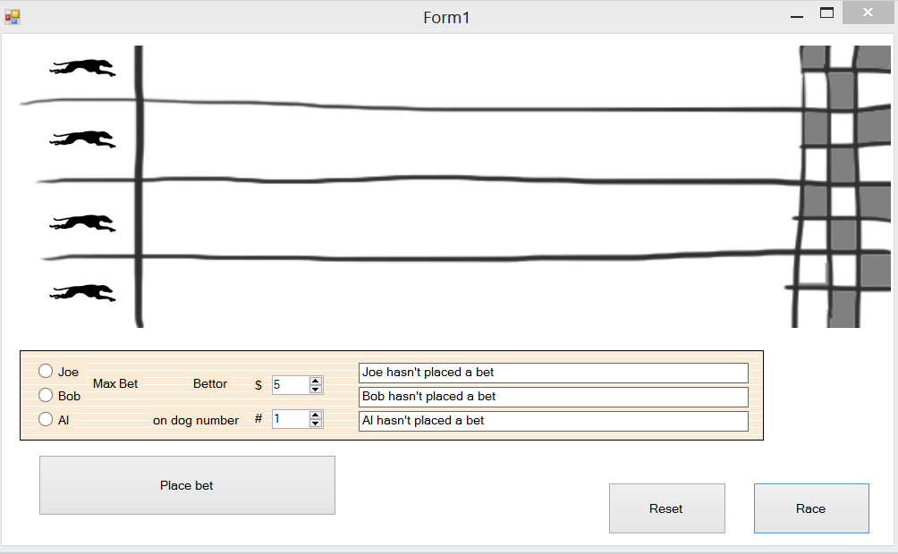The game ends when everyone has lost their money, or there is only one bettor left.
   4. **The bettors must show**

* The maximum amount that can be bet for each bettor in a label
* 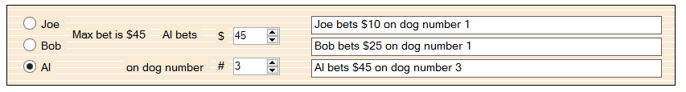The Up/down box can only go to that maximum number for each bettor. (i.e.: Al’s max bet is $45)
* 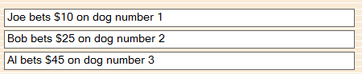When the Bet is laid the Name, Amount, and Dog appear on the right
* 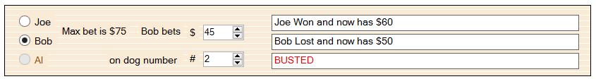When a person is out of money, **they cannot bet again** (in this case the radio button is inactive), and Busted appears
* When all the bettors lose (which they eventually will) the game is over

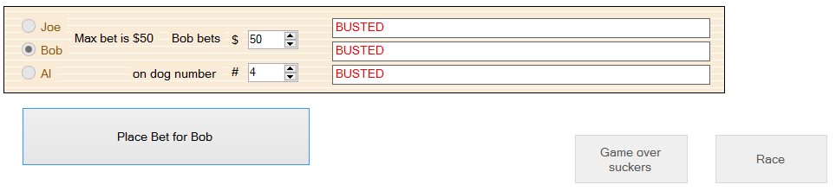

You must use the **Factory Design Pattern**, and an **Abstract Class** for the Punters. The 3 punters are to inherit from the Punter class.

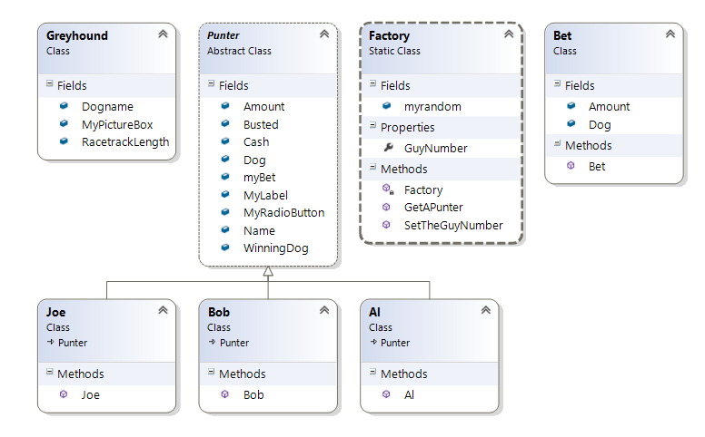

1. Create at least **1 Unit Test** of your project using Instantiation and linking back to the class.

Write a log of your work

**Comment your code thoroughly explaining what each major portion does**

## Form features

* Data entry text boxes or listboxes, and labels
* Buttons or Radio buttons or any other clickable event to manipulate data
* Adequate signage and titles to make it easy to understand.

### Hints.

The exercise uses Classes and Arrays they are the heart of the program and make the code quite short.

Look at the book **C# Head First** for help to make your program.

Look at the exe in the Goodies folder and see how it works.

**DO NOT make your program look like a bunch of Greyhounds as these images show above.** Use your imagination and Coding Ninja skills to change it into something far more entertaining and surprise us.

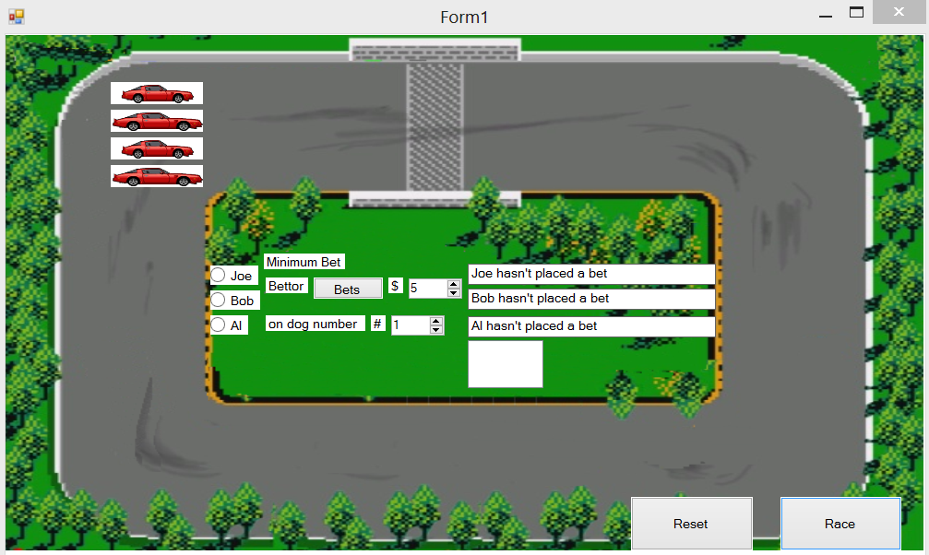

**This is my adaption, the cars go around the track.**

**Beat that …..**

### Marking Schedule

|  |  |  |
| --- | --- | --- |
|  | Form features | |
|  | 1.1 | The maximum amount that can be bet for each bettor in a label |
|  | 1.2 | The Up/down box can only go to that maximum number for each bettor |
|  | 1.3 | When the Bet is laid the Name, Amount, and Dog appear on the right |
|  | 1.4 | When a person is out of money, **they cannot bet again** |
|  | 1.5 | When all the bettors lose (which they eventually will) the game is over |
|  | Class Operations | |
|  | 2.1 | Two classes Greyhound and Bet (Bet is optional) |
|  | 2.2 | An Abstract Punter class |
|  | 2.3 | Three inherited bettor classes |
|  | Unit test | |
|  | 3.1 | A unit test using Instantiation |

|  |  |  |  |  |
| --- | --- | --- | --- | --- |
| **% of Grade** | **Excellent 100%** | **Adequate 80%** | **Poor 60%** | **Not Met 0%** |
|
| **Program Specifications / Correctness** | | |  |  |
| 50% | No errors, program always works correctly and meets the specification. | Minor details of the program specification are violated, program functions incorrectly for some inputs. | Significant details of the specification are violated, program often exhibits incorrect behavior. | Program only functions correctly in very limited cases or not at all. |
| **Mark** | 50 | 40 | 30 | 0 |
| **Readability** | | |  |  |
| 20% | No errors, code is clean, understandable, and well-organized. | Minor issues with layout, variable naming, or general organization. | At least one major issue with layout, variable names, or organization. | Major problems with at three or four of the readability subcategories. |
| **Mark** | 20 | 16 | 12 | 0 |
| **Documentation** | | |  |  |
| 20% | No errors, code is well-commented. | One or two places that could benefit from comments are missing them **or** the code is *overly* commented. | Complicated lines or sections of code uncommented or lacking meaningful comments. | No comments present. |
| **Mark** | 20 | 16 | 12 | 0 |
| **Code Efficiency** | | |  |  |
| 5% | No errors, code uses the best approach in every case. | *N/A* | Code uses poorly-chosen approaches in at least one place. | Many things in the code could have been accomplished in an easier, faster, or otherwise better fashion. |
| **Mark** | 5 | 4 | 3 | 0 |
| **Assignment Specifications** | | |  |  |
| 5% | No errors | *N/A* | Minor details of the assignment specification are violated, such as files named incorrectly or extra instructions slightly misunderstood. | Significant details of the specification are violated, such as extra instructions ignored or entirely misunderstood. |
| **Mark** | 5 | 4 | 3 | 0 |